Determining Magnetic Properties of a Domain with Matlab and Analytical Solutions

Author: Ellisa Booker  
[tug67203@temple.edu](mailto:tug67203@temple.edu)

Group: Ellisa Booker, Luciana Arce, Eric Seip

# Introduction

In this project, we determined various magnetic properties of a domain with a conductor at its center, and 2 bars of iron along the sides. A diagram of the domain is shown in Figure 1 below. The purpose of this project was to strengthen both our Matlab skills and magnetics skills by combining our knowledge on both subjects to analyze a complex problem.

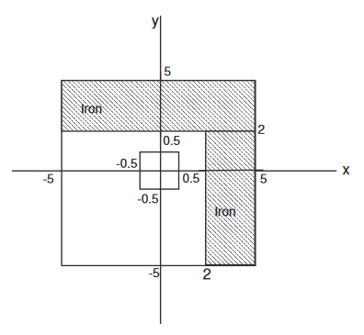

Figure 1. The given domain with 2 iron bars, and a copper conductor in the middle

The following sections detail the various procedures that we performed to complete this project, as well as our results and further topics for discussion.

# Procedure

1. *Step 1: Finding µ (magnetic permeability) and J (volume current density)*

The first steps of our project included determining variables such as N, the number of nodes in our domain, as well as delta X and Y, the distance between each node. For our project, we chose N = 41, and delta X = delta Y = 1cm/N. These calculations were then used to determine the location of the conductor and iron bars within the domain, which allowed for calculating magnetic permeability and volume current density. To solve for µ, we needed 3 different equations for the 3 different areas including: µ inside the 1st iron bar, µ inside the 2nd iron bar, and µ everywhere else in the domain. Each equation was a variation of Equation 1 shown below.

$$μ_{(i,j)}= μ_{r(i,j)}* μ_{0}$$

$$μ_{0}=4π*{10}^{-7}$$

Equation 1. The equation to find $magnetic permeability$

Using our values of N and delta X/Y along with the given lengths of each iron bar on Figure 1, we were able to determine that Iron bar 1 was located on nodes (1:13 x, 1:41 y) and Iron bar 2 was located on nodes (1:41 x, 28:41 y). For these values of (i,j), µr = 5000, which is the µr of iron and **µ = 0.0628**. Everywhere else in the domain, µr = 1, which was the given value for the domain and **µ = 1.25e-05**. These were the same values I got when solving the problem analytically as well.

To find the volume current density, we simply divided the current by the cross-sectional area of the conductor, since that was the only place where current flowed in this problem. We used Equation 2 shown below for these calculations.

$$J_{(i,j)}= I/A_{cross-section}$$

Equation 2. The equation to find $volume current density$

Using the same method that was used to find the location of the iron bars, we determined that the located of the conductor was nodes (19:23 x, 19:23 y). For these values of (i,j), **J = 10e4** and elsewhere, **J = 0**. This is consistent with the numerical values I got when solving the problem analytically.

1. *Step 2: Finding M (magnetization) and A (magnetic potential)*

In order to solve for magnetic potential, we first had to solve for magnetization. This equation followed the same approach as laplace equations from the previous project, relying on values of the µ that we calculated above. The equation used is shown in Equation 3 below.

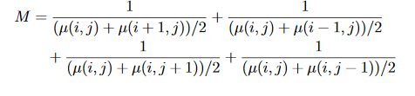

Equation 3. The equation to find $magnetization$

This calculated a scalar number for each position of (i,j) which was then used in the equation for magnetic potential. That equation is shown below in Equation 4.

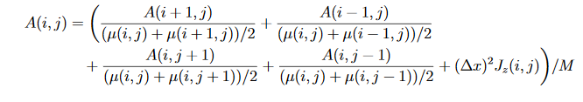

Equation 4. The equation to find $magnetic potential$

Equation 4 is very similar to the laplace equation used to solve for V in Project 1. This equation generated an array of A values which were then used to create a contour plot, shown in Figure 4 of the results section.

1. *Step 3: Finding B (magnetic flux density)*

The final step was to calculate for magnetic flux density. To do this, we first calculated flux density in the Ax direction, then in the Ay direction, and found their total magnitude. The specific equation is shown below.

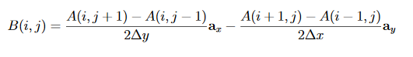

Equation 5. The equation to find $magnetic flux density$

The next section shows the result of our calculations and offers brief analysis of the resulting graphs.

# Results

Below is the contour map of the magnetic flux density, B. The yellow lines on this plot show areas of highest flux density while the purple lines show the lowest.

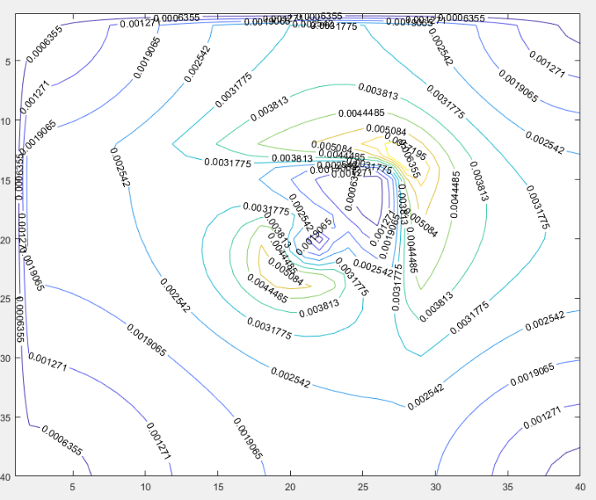

Figure 2. Contour map of magnetic flux density

There are 2 areas of high flux density on this map. The first is seen towards the top right of the map, which occurs at the intersection of the 2 iron bars. The second area of high density occurs towards the left center of the map, where the conductor is. This makes sense, since the flux density should be highest where it is circulating around a conductor, and where that circulation runs into interference, like the iron bars)

The same effect is shown in the quiver plot of flux density, seen in Figure 3.

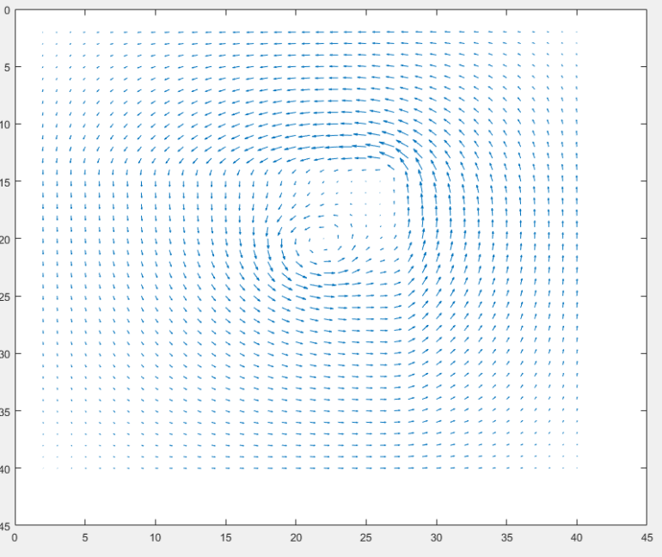

Figure 3. Quiver plot of magnetic flux density

In this quiver plot, it is easier to see the direction and motion of the flux density lines as they circulate around the conductor and condense at the intersection of the iron bars.

Below is the contour map of the magnetic potential, A. The yellow lines on this map shown areas of the highest magnetic potential. 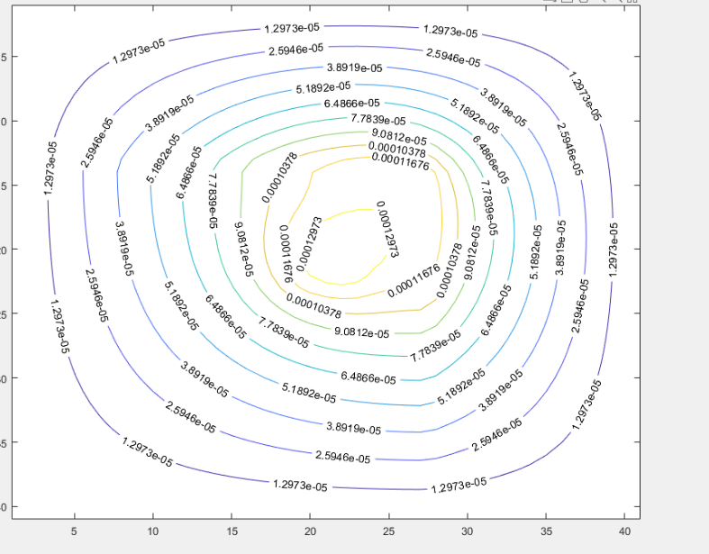

Figure 4. Contour plot of magnetic potential

The shape of this graph is a circle centered around the conductor. The values of the highest potential are centered around the conductor and gradually get weaker as they radiate outwards. This is consistent with my understanding of magnetic potential, as it is highest when surrounding a conductor.

The following section offers brief discussion on some of the other project topics not discussed in the results section.

# Discussion

**Consider any closed loop with the conductor inside the loop. Does Ampere’s law hold true? What about for Any closed loop that does not include the conductor?**

Ampere’s law does not hold true for any closed loop with a circular conductor inside, since there would not be symmetry. Bios-Savart’s law should be used instead. For a closed loop that does not contain the conductor, Ampere’s law does hold true.

**Suppose the conductor carries an alternating current at 60Hz. How would the magnetic field vary as a function of time?**

To visual how the magnetic field would vary with time, it is helpful to think of the right-hand rule. Using the right-hand rule, we see that magnetic field circulates clockwise when current is coming out of the page, and counterclockwise when current is going into the page. This means that if current alternates direction, the magnetic field will alternate direction as well. The speed at which it alternates is determined by the frequency, or 60 cycles/second in this case.